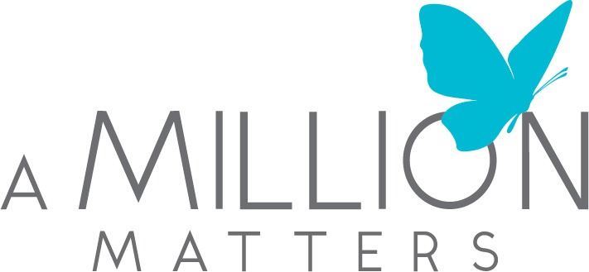

Grant Application

Legal Name of Organization ____________________________________________________

Address ____________________________________________________________________

____________________________________________________________________

Website ______________________________________ Telephone ____________________

Executive Director ______________________________ Email ________________________

IRS 501(c)(3) effective date _______________________ Tax ID number _________________

Is your organization affiliated with a religious or private educational institution?
Yes ____
No ____

If your organization is affiliated with a religious or private educational instituton, please identify that institution and explain the nature of the affiliation.
(150 words max)

Which counties does your organization serve? (Must be Fulton, Clayton, Cobb, DeKalb, and/or Gwinnett counties – mark all that apply).
Fulton ____
Clayton ____
Cobb ____
DeKalb ____
Gwinnett ____

What is the population served by your organization annually (who, where and how many)?
(250 words max)

Please provide your organization’s mission statement and goals.
(500 words max)

Please provide a summary of the history of your organization.
(500 words max)

Please describe your organization’s current programs and accomplishments.
(1000 words max)

Please provide a summary of the purpose of your proposed program or project to be funded by our $100,000 award grant. This summary should include: (1) a description of the specific needs the project(s) address(es); (2) a statement on how the project(s) will benefit your target population; (3) a timeline for the implementation of the project(s); (4) an explanation of how the project(s) will be staffed; (5) the organization’s long-term strategy for funding the project(s); and (6) methods for evaluating the effectiveness/success of the project(s).
(1500 words max)

Along with your application, the following supplemental material must be submitted in the onlineapplication. *Each submission must have your organization’s name on it *

- A detailed project budget that equals $100,000 (specifics are required, e.g., playground equipment, $XX; Paving $YY)
- The organization’s two most recent audited financial statements. If the most recent audited financial statements do not include 2023, please submit statements for 2021 and 2022, in addition to internal financial results for 2023 that include budget to actual expenses.
- Projected budget for 2024
- 501(c)(3) IRS cover letter
- Listing of Board of Directors
- Annual Report, if available
- Brochure of the Organization, if available

